CS/CE 224/272
Object Oriented Programming and Design Methodologies
Project Title | GrabNob
Team Title (as on Canvas) | Project Group 42
Team Members’ Details | Name | ID | Section
Team Member 1 | Ali Asghar | 10229 | T4
Team Member 2 | Mughees Siddiqui | 10047 | T4
Team Member 3 | Maaz Siddiqui | 09980 | T4

Introduction
Our project is a simple SFML-based application called GrabNob, made for Habib students to easily receive their order from HobNob. The app lets students register or log in to their account, view the cafe’s menu, order sandwiches or even make one how they like it, desserts, or drinks, and even set a pickup time so their food is ready between classes to reduce them from stressing over getting late to classes. Students can also choose to pay online or by cash when placing an order. The goal of this project is to save students time and let them have food according to their preference.

More about GrabNob

1.1 Application Overview
GrabNob is a digital food ordering application developed for Hobnob Bakery at Habib University. It enables students to browse, select, and order food items from Hobnob’s menu conveniently through an online platform. The app focuses on providing a cashless, quick, and user-friendly experience by integrating features such as an online payment system, balance management, and categorized menu browsing.

1.2 Users
The users in this application are the students of Habib University. Each student can create an account by registering with their student ID and password. Once logged in, students can access their personal dashboard, view their current balance, explore the menu, and place food orders.
- User Roles:
  - New User: Can register an account and set an initial balance.
  - Registered User: Can log in, order food, view balance, and make payments.

1.3 Menu and Categories
The menu is divided into multiple categories, each containing different types of items:
- Bakery Items: e.g., Sandwiches, Pizza Slices, Brownies
- Sweeteners: e.g., Cookies, Donuts, Cakes
- Savoury: e.g., Burgers, Fries, Rolls
- Beverages: e.g., Coffee, Tea, Juice
Each category holds a list of items, and every item has a name, price, and available quantity (stock). If the quantity reaches zero, the item is marked as out of stock, ensuring realistic stock management. Keep in mind these categories are tentative and may change as we move forward!

1.4 Shopping Cart System
The Shopping Cart allows users to add, remove, and view items before finalizing an order. It automatically calculates the total bill based on selected items and their prices. Users can review their cart contents and modify their choices before proceeding to checkout.

1.5 Balance and Payment System
Each student has a virtual balance (wallet) associated with their account. This balance can be recharged (deposited) and is used to make online payments during checkout.
Payments are handled through an Online Payment System, where users confirm their purchase and the total amount is automatically deducted from their balance.
Only online payments are supported, as the app operates entirely in a digital environment within the university ecosystem.

1.6 Login and Account Management
Students can register, log in, and save their account data securely. The system ensures that each student’s credentials and balance are stored persistently, allowing them to access their account anytime. After transactions, balances are automatically updated and saved.

1.7 Application Flow
- Login / Registration
- User logs in or registers a new account.
- Browse Menu
- User explores categories and views available items.
- Add to Cart
- User adds desired items to their shopping cart.
- Checkout
- User proceeds to payment and confirms the order.
- Online Payment
- The total cost is deducted from the user’s balance.
- Balance Update
- The user’s updated balance is displayed for future orders.
The main goal of GrabNob is to simplify the on-campus food ordering experience by providing a digital platform that’s efficient, intuitive, and reliable. It reduces waiting time, eliminates the need for cash transactions, and ensures transparency in billing and balance management — all while demonstrating solid OOP design and structure.

UML Diagram
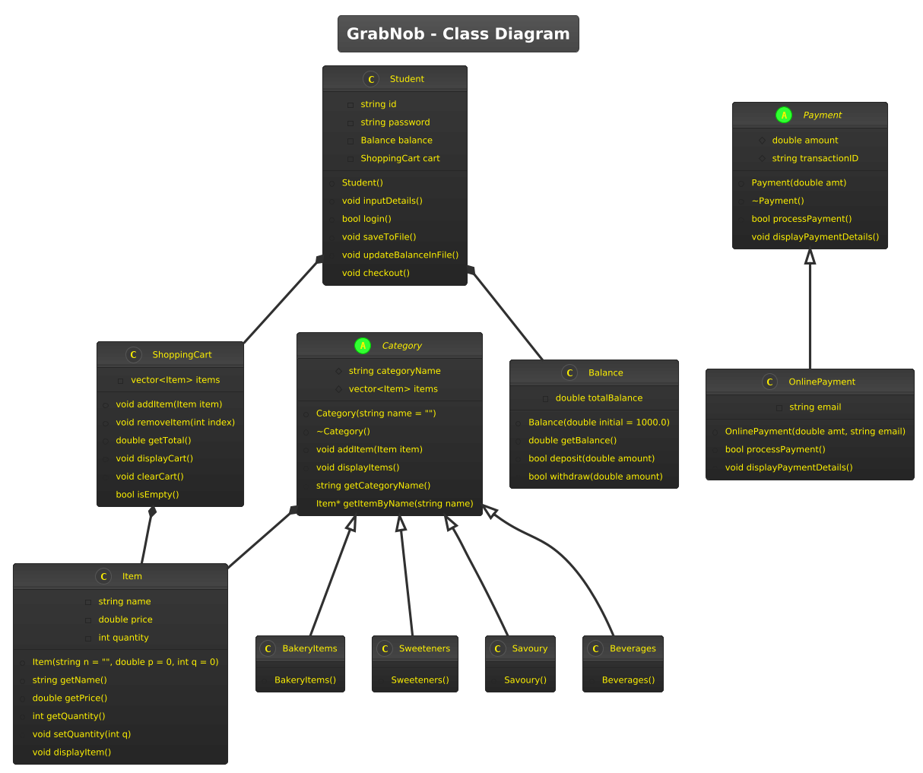

Application Initial Login Window